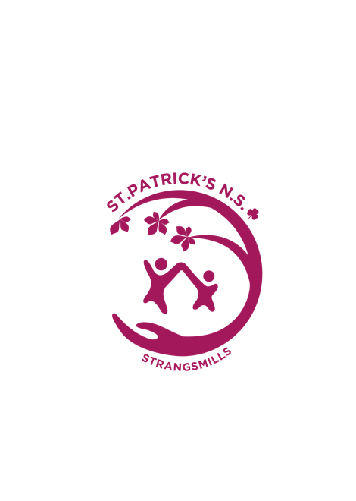

**St Patrick’s NS Strangsmills - ANNUAL ADMISSION NOTICE**

**in respect of admissions to the 2025/2026 school year**

**Admission Policy and Application Form**

A copy of the school’s **Admission Policy** and the **Application Form for Admission** for the 2025/2026 school year is available as follows: –

To download at: <http://www.strangsmillsns.ie/pages/enrolment.php>

On request: By emailing [schooloffice@strangsmillsns.ie](mailto:schooloffice@strangsmillsns.ie) or writing to: school address above or phone (051) 874474

**Admissions to the 2025/2026 school year**

**Application and Decision Dates for admission to 2025/2026**

The following are the dates applicable for admission to Junior Infants

|  |  |
| --- | --- |
| The school will commence accepting applications for admission on | **November 25th 2024** |
| The school shall cease accepting applications for admission on | **January 17th 2025** |
| The date by which applicants will be notified of the decision on their application is | **February 5th 2025** |
| The period within which applicants must confirm acceptance of an offer of admission is | **February 14th 2025** |

**Note: the school will consider and issue decisions on late applications in accordance with the school’s admission policy.**

**\*\*Failure to accept an offer within the prescribed period above may result in the offer being withdrawn\*\***

**Number of places being made available in 2025**

|  |  |
| --- | --- |
| The number of places being made available in junior infants is | **28** |